............................,December ........2022
CAM QUANG PRIMARY SCHOOL
THE FIRST TERM TEST – ENGLISH 4
School year: 2022 – 2023

Fullname: ………………………………………………..……………… class: 4 ……………….
Total Marks  (L, R, W + Speaking) | Teacher’s remarks
PART I. LISTENING:
Question 1: Listen and number. There is one example (0).
a.  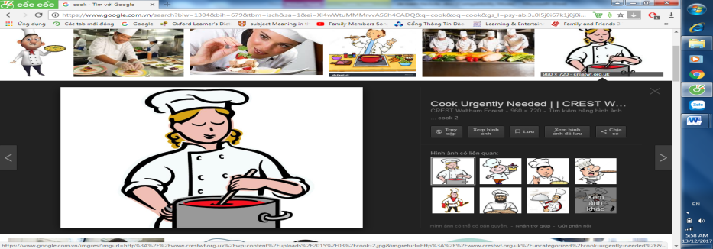  0 | b.  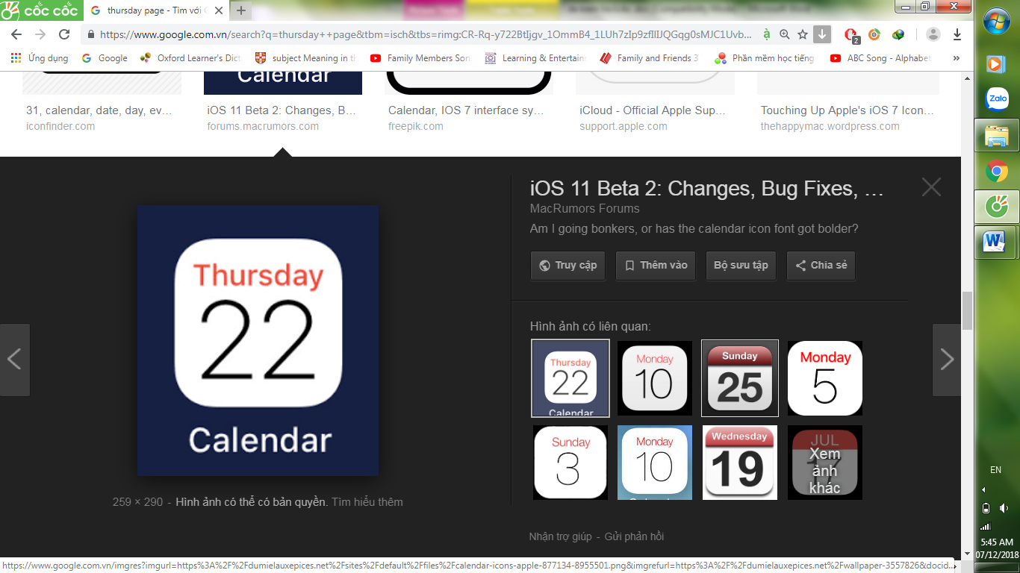 | c.  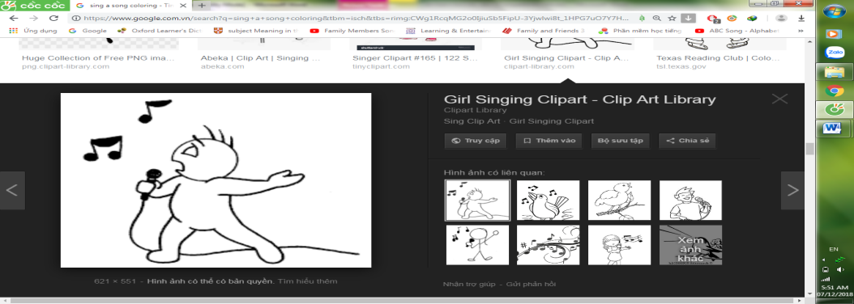 | d.  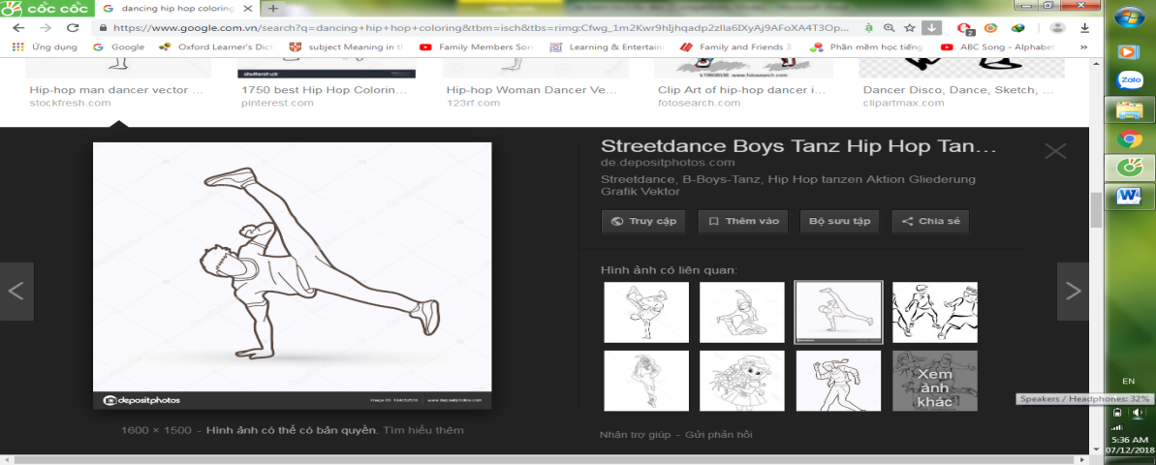 | e.  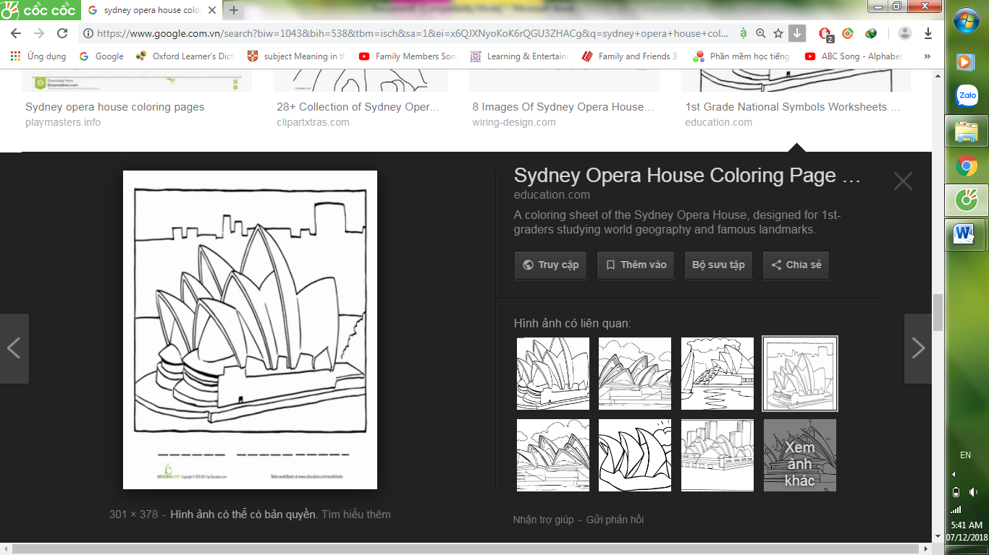
Question 2: Listen and circle the correct answer. There is one example (0).
0. Phong can………..
A. draw B. dance C. skip
- Tom was ............. yesterday morning.
A. at school B. at home C. at the zoo
- What’s Nam doing? He is ................................................................
A. reading a text B. watching a video C. writing a dictation
- What did you do on the beach? I played ...........................................................
A. football B. volleyball C. basketball
- Linda’s birthday is on the ..............
A. July 26 B. March 6 C. June 16

Question 3. Listen and complete. There is one example (0).
0. Tom was at school yesterday morning.
- Hakim is from ……………….......................................
- What can you do? I can ………………...............
- I have PE on ………………..........................and Thursdays.
- What’s Nam doing? He’s ……………….................................a book.

PART II: READING.
Question 1: Look and read. Put a tick (√ ) or cross (X) in the box.
1.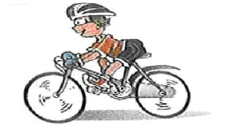 He can dance. | 2. It’s on the sixteenth of October
  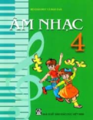  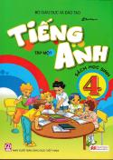  3. I have Maths, Vietnamese and Music | 4.  I am from England
Question 2: Read and complete:
Dear Nam,
I‛m Hakim. Yesterday was fun and relaxing. I got up late. In the morning, I cleaned my room. In the afternoon, I watered flowers in the garden. Then I did my homework. In the evening, I chatted online with my friend Quan. We talked about our favourite films. What did you do yesterday?
Hakim,
1. Hakim ........................................................................ late yesterday.
2. He ............................................................................... yesterday morning.
3. Yesterday afternoon, he .............................................................................
4. Then he ....................................................................................................
5. He ........................................................................................ in the evening.

PART III: WRITING.
Question 1. Look and write. There is one example (0).
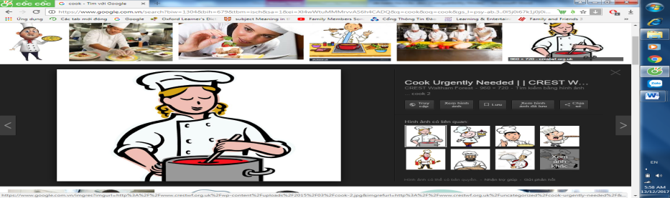 | 0. What’s she doing?  She’s cooking. | 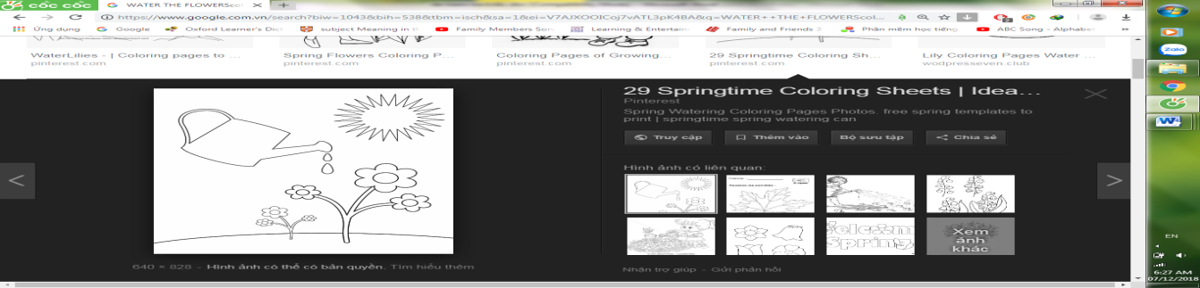 | 3. What did you do yesterday?  I ........................................  ...........................................
  Le Loi Street | 1. Where’s your school?  It’s ................................  ............................................. | 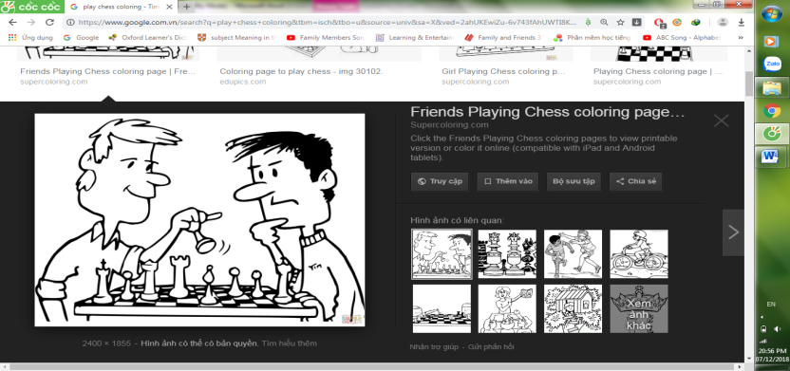 |  | 4. What are they doing?  They’re ......................  ..........................................
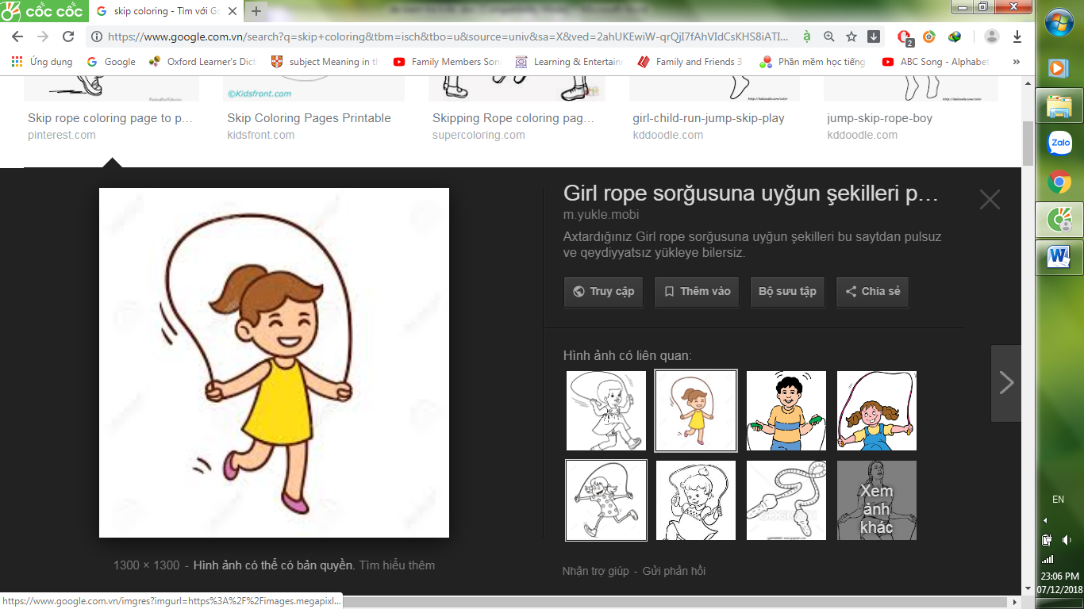 | 2. What can she do?  She can ………..…....... | 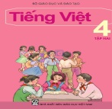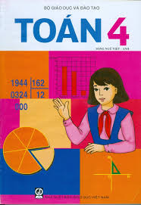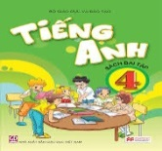 |  | 5. What subjects do you have on Fridays?  I have ..........................  ..........................................
Question 2. Reorder the words.
0. in / 4A / I / Class / am /. I am in Class 4A.
1.are/ drawing/ Nam/ and/ Phong/ house/ a/ ./
……………………...…………..........................................................................……………………
- school/ where/ your/ is/ ?/
………………………………………….....................................…………...………………………
- you/ piano/ play/ did/ yesterday evening/ the/ ?/
……………………………………...........................................………………….……………………
- in/ is/ my/ Cam Thanh/ Village/ school/ ./
………………………………................................................................………………………………
5. school / I / at / yesterday / was / morning / .
…………………………………………….....................……………………………………………
6. What / have / you / today / subjects / do /?
………………………………………................…………………………………………………

