**THE FIRST TERM TEST- ENGLISH 3**

**SCHOOL YEAR : 2022 – 2023- TIME : 40’**

|  |  |  |  |
| --- | --- | --- | --- |
| **Full name:** …………………………………. | **Mark: /10** | | |
| **School: Cam Quang Primary School** | **Listening** | **Reading** | **Writing** |
| **Class: 3**……… | **/3.0** | **/5.0** | **/2.0** |

**A.LISTENING**

**1.Listen and draw lines. There is one example.(4 questions - 1.0 point)**

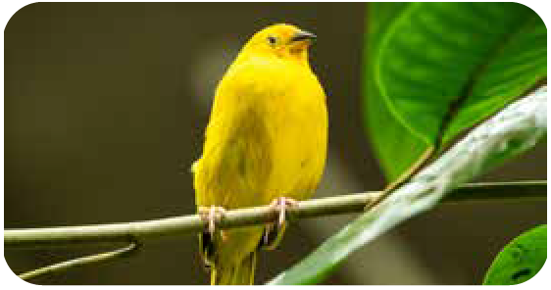0. **A.**

**Ex.**  ⚫

1. **B.**

 ⚫

2. **C.**

 ⚫

3. **D.**

⚫

4. **E.**

 ⚫



**2. Listen and put a tick (✓) in the box. There is one example.(4 questions - 1.0 point)**

|  |  |  |  |  |
| --- | --- | --- | --- | --- |
| Ex. | 5. | 6. | 7. | 8. |
| a.Monday  ✓  b.Wednesday | a.Thursday  b.Saturday | a.Tuesday  b.Friday | a.Wednesday  b.Sunday | a.Friday  b.Tuesday |

**3. Listen and color. There is one example.(4 questions - 1.0 point)**

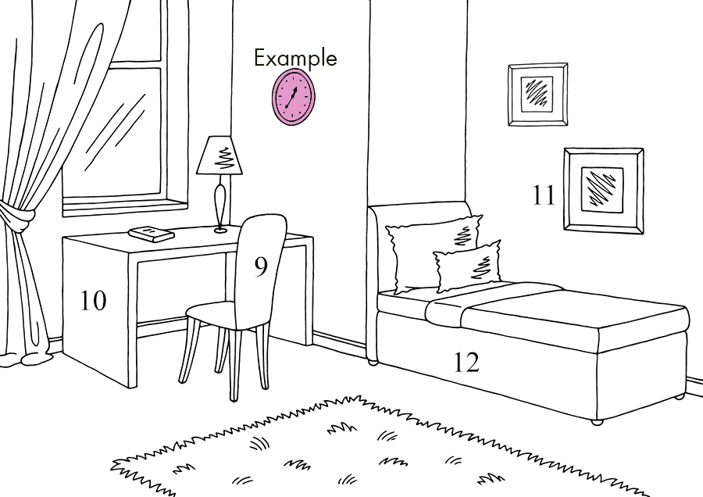

**B.READING**

**1.Look, read and draw lines. There is one example.(3 questions - 1.5 points)**

|  |  |  |  |
| --- | --- | --- | --- |
|  |  |  |  |

**1. ⚫ 2. ⚫ 3. ⚫ 4. ⚫**

**A.**Go to bed!  **B.**Clean your room!  **C.** Do your homework!  **D.** Wakeup!

**2.Look, read and tick (✓)Yes or No.There is one example.(3questions -1.5pts)**

|  |  |  |  |  |
| --- | --- | --- | --- | --- |
|  |  |  | **YES** | **NO** |
| **Ex.** |  | This is my pencil. | ✓ |  |
| 4. | màu  hồng | My favorite color is pink. |  |  |
| 5. |  | My dad is in the yard. |  |  |
| 6. |  | I have a pet cat. |  |  |

**3.Look, read and circle. There is one example.(4 questions - 2 points)**

My name is Joanna. I’m eight years old. I’m from Canada. I live on Carolina Street in Vancouver with my family. There are four people in my family, my dad, my mom, my sister Sophia and me. My house has two bedrooms, a living room, a kitchen, a bathroom and a yard. My favorite room is my bedroom. It’s blue and white. My bedroom has two blue beds, a white closet and a white desk with two chairs for me and my sister.

**Ex.** Her name is Joanna / Sophia.

7. She live with her family / brother.

8. There are five / six rooms in her house.

9. Her bedroom is blue and white / blue and pink.

10. There are two / one chair(s) in her bedroom.

**C.WRITING:**

**1.Order the letters. There is one example.(3 questions - 0.75 points)**

|  |  |  |  |
| --- | --- | --- | --- |
| **Ex.** |  | e d b | *b e d* |
| 1. |  | e p s e l g i n | __ __ __ __ __ __ __ __ |
| 2. |  | i i v r o m o l n g | __ __ __ __ __ __ __ __ __ __ |
| 3. |  | a o i v f r e t | __ __ __ __ __ __ __ __ |

**2.Look and write. There is one example.(3 questions - 0.75 points)**

|  |  |  |
| --- | --- | --- |
| **Ex.** |  | What’s in the bedroom?  A b e d |
| 4. |  | What’s Tom doing?  He is__ __ __ __ __ __ __ __ . |
| 5. |  | Where are you from?  I’m from __ __ __ __ __ . |
| 6. |  | Are these your __ __ __ __ __ __ __ __ __?  Yes, they are. |

**3.Reorder the words to make a correct sentence. There is one example(2 questions - 0.5 pts)**

Stand

up

, please.

**Ex.**

*Stand up, please.*

🡪

these

Are

your

pencil cases?

7.

🡪

singing?

Do

like

friends

your

8.

🡪

**THE END.**