Teaching date: 16/12/2024
WEEK 15:
Period 57:

UNIT 4 – ACTIVITIES
Lesson 4.3 (page 59)

- Objectives
By the end of this lesson, students will be able to use useful language talk about what people are doing at different places.
Language knowledge and skills
Vocabulary: studio, soccer field, arcade, skate park, coffee shop
Sentence patterns: What's she doing?
She's dancing at the studio.
What are they doing?
They're playing soccer at the soccer field.
Skills: Listening, Reading, Writing, and Speaking
  - Competences
Self-control and independent learning: identify and use useful language talk about what people are doing at different places.
Communication and collaboration: work in pairs or groups to use useful language talk about what people are doing at different places.
Critical thinking and creativity: learn how to use useful language talk about what people are doing at different places.
  - Attributes
Kindness: support their friends to complete the learning tasks or play the games.
Diligence: focus on the lesson and work hard to complete all the tasks.
Honesty: play fair.
Accountability: appreciate kindness, diligence, and honesty.
- Teaching aids and materials
- Teacher’s aids: Tiếng Anh 4 i-Learn Smart Start Student’s Book and Teacher’s book, Class CDs, Flashcards, DCR & DHA on Eduhome, Projector/Interactive Whiteboard /TV (if any), PowerPoint slides.
- Students’ aids: Tiếng Anh 4 i-Learn Smart Start Student’s Book, Workbook, Notebook.
- Procedures
- Warm-up (5 minutes)
- Objectives: To help students have some general ideas about listening.
- Content: Playing the game: “Listen and run” or “Tic tac toe”.
- Expected outcomes and assessment
- Task completed with excellence: Students can listen and choose the right flashcards correctly and quickly.
- Task completed: Students can listen and choose the right flashcards.
- Task uncompleted: Students fail to listen and choose the right flashcards.
- Organization
Teacher’s activities | Students’ activities
Listen and run game.  - Divide the class into two teams.  - Place the flashcards about the places on page 57 on the board.  - Turn on the audio once so that the students can hear the word.  - Say “Run” and then the student from each team has to run quickly to find and grab the flashcard and they have to repeat the word.  - The team with the most flashcards at the end wins.  - Lead in the new lesson. | - Work with their teammates to complete the task.  - Look at the flashcards on the board.  - Carefully listen to the word in the audio and quickly grab that flashcard.
- Main lesson (10 minutes)
- Reading
- Objectives: To help the students have some general ideas about the reading.
- Content: Reading and Listening.
- Expected outcomes and assessment
- Task completed with excellence: Students can read and circle the right answer correctly and quickly.
- Task completed: Students can read and circle the right answer.
- Task uncompleted: Students fail to read and circle the right answer.
- Organization
Teacher’s activities | Students’ activities
E. 1. Read and circle True or False.  - Use DCR on Eduhome to show the class the text on page 59.  - Have students read the text individually.  - Read the text as a whole class.  - Demonstrate the activity using the example.  - Have students read and circle "True" or "False."  Check answers as a whole class. | - Listen and follow their teacher’s instructions.  - Work individually to complete the task.  - Read and circle "True" or "False."
- Writing (10 minutes)
- Objectives: To help the students know how to make their own paragraphs.
- Contents: Reading and Writing.
- Expected outcomes and assessment
- Task completed with excellence: Students can know how to make their own paragraphs naturally.
- Task completed: Students can know how to make their own paragraphs.
- Task uncompleted: Students fail to know how to make their own paragraphs.
- Organization:
Teacher’s activities | Students’ activities
F. Look at E. Choose five friends and write about their hobbies.  - Have the students read the text in Part E again.  - Have students fill in the blanks to make their own paragraphs.  - Give the students enough time to make their own paragraphs using their own ideas.  - Walk around the class and support them if necessary.  - Invite some students to present their paragraphs in front of the class.  - Help the students with feedback and correct them if any. | - Read the text in Part E again.  - Fill in the blanks to make their own paragraphs.  - Present their paragraphs in front of the class.
- Speaking (5 minutes)
- Objectives: To help them remember the vocabulary items and sentence patterns about their friends' hobbies.
- Content: Asking and answering or playing the game: here was it?”.
- Expected outcomes and assessment
- Task completed with excellence: Students can correctly use vocabulary items and sentence patterns about their friends' hobbies.
- Task completed: Students can use the vocabulary items and sentence patterns about their friends' hobbies.
- Task uncompleted: Students cannot use the vocabulary items and sentence patterns about their friends' hobbies
- Organization
Teacher’s activities | Students’ activities
G. Talk about your friends' hobbies  Divide the class into pairs.  - Have pairs talk about their friends' hobbies.  - Instruct students to use structures such as: “He/ She likes doing something; Her/his hobby is doing something; What do you like doing in your free time?”  Afterward, have some pairs talk about their friends' hobbies in front of the class | - Work with their partner to complete the task.  - Talk about their friends' hobbies in front of the class
- Consolidation and homework assignment (5 minutes)
- Objectives: To help students remember and pronounce the vocabulary items about their friends' hobbies.
- Contents: Playing the game “Whispers” or “What’s the picture?” and assigning homework in the Workbook.
- Expected outcomes and assessment
- Task completed with excellence: Students can whisper the words to their friends correctly and smoothly.
- Task completed: Students are able to whisper the words to their friends.
- Task uncompleted: Students fail to listen the new words or whisper them to their friends.
- Organization
Teacher’s activities | Students’ activities
Consolidation  Option 1: Whispers game  - Have the students play the game “Whispers.”  - Divide the class into two teams.  - Ask the students to form two lines.  - Whisper a word to the first student from each group. Then they whisper the word into the ear of the student standing next to them. They continue whispering the word until the end of the line. The last student has to say it out loud.  - The first student to say the correct word wins a point for their team.  - The team having more correct answers will win the game. | - Play the game “Whispers” with their teammates.  - Follow their teacher’s instructions before playing the game.  - Quickly whisper the word into the ear of the friend standing next to them.
Option 2: “What’s the picture?” game  - Invite a student to come to the front of the class and whisper the name of an object s/he has to draw.  - The student draws the picture on the board for the rest of the class to guess what it is.  - The first student to guess the object correctly comes to the front of the class to draw the next picture.  - Repeat until all of the target vocabulary has been used. | - Follow their teacher’s instructions before playing the game.  - Draws the picture on the board for the rest of the class to guess what it is.
Homework Assignment  - Require students to do exercises on page 39 in the Workbook.  - Have them copy new words and structure in their Tiếng Anh 4 i-Learn Smart Start Notebook, page 25.  - Ask them to prepare Unit 4 – Review and Practice on page 60 in the Student’s Book. | - Follow their teacher’s instructions.  - Prepare the new lesson.

Teaching date: 16/12/2024
WEEK 15:
Period 58:
UNIT 4 – ACTIVITIES
Review and Practice (page 60)

1.Objectives
By the end of this lesson, students will be able to review say if they are doing an activity, ask what other people are doing, and ask where other people are doing an activity.
1.1. Language knowledge and skills
Vocabulary: market, skate, water park, do a puzzle, read a comic book, take photos.
Sentence patterns: This is Minh. He is playing soccer at the soccer field.
Skills: Listening, Reading, Writing, and Speaking.
1.2.Competences
Self-control and independent learning: review say if they are doing an activity, ask what other people are doing, and ask where other people are doing an activity.
Communication and collaboration: work in pairs or groups to if they are doing an activity, ask what other people are doing, and ask where other people are doing an activity.
Critical thinking and creativity: learn how to if they are doing an activity, asking what other people are doing, and asking where other people are doing an activity.
1.3. Attributes
Kindness: support their friends to complete the learning tasks.
Diligence: focus on the lesson and work hard to complete all the tasks.
Honesty: play fair.
Accountability: appreciate kindness, diligence, and honesty.
2.Teaching aids and materials
- Teacher’s aids: Tiếng Anh 4 i-Learn Smart Start Student’s Book and Teacher’s book, Class CDs, Flashcards, Digital Book (DCR & DHA on Eduhome), Projector/Interactive Whiteboard /TV (if any), PowerPoint slides.
- Students’ aids: Tiếng Anh 4 i-Learn Smart Start Student’s Book, Workbook, Notebook.
3.Procedures
A.Warm-up (5 minutes)
a.Objectives: To help the students review the previous lessons, generate the students’ interests, and lead in the Review and Practice lesson.
b.Content: Playing the game: “Roll the dice” or “What’s missing?” game
c.Expected outcomes and assessment
- Task completed with excellence: Students can remember the words in each category or identify the vocabulary items on the flashcards quickly and correctly.
- Task completed: Students can remember the words in each category or identify the vocabulary items on the flashcards.
- Task uncompleted: Students are unable to remember the words in each category or identify the vocabulary items on the flashcards.
d.Organization
Teacher’s activities | Students’ activities
What’s missing?  - Display the flashcards about activities and places learned in unit 4 on the board.  - Point to each one in turn for students to say the word. Give the class a few seconds to look at them.  - Ask students to turn around. Remove a card.  - Students look at the board again as you say “What’s missing?”  - When students have identified the missing card, shuffle the cards again and repeat the procedure. | - Follow their teacher’s instructions before playing the game.  - Look at the flashcards and identified the missing card
- Main lesson
- Listening (5 minutes)
- Objective: To help the students listen for the right information and identify the activities of different people.
- Content: Listening.
- Expected outcomes and assessment
- Task completed with excellence: Students can listen and draw lines correctly.
- Task completed: Students can listen and draw lines.
- Task uncompleted: Students are unable to listen and draw lines.
- Organization
Teacher’s activities | Students’ activities
A. Listen and draw lines.  - Use DCR on Eduhome to show the class the pictures on page 60.  - Have students look at the pictures and call out the activities and people they can see.  - Play audio and demonstrate the activity using the example.  - Play audio. Have students listen and draw lines.  - Play audio again and check answers as a whole class. | - Look at the pictures and call out the activities and people they can see.  - Listen and draw lines.
- Reading (10 minutes)
- Objectives: To practice reading and filling in the blanks.
- Contents: Reading, Writing
- Expected outcomes and assessment
- Task completed with excellence: Students can read the sentences and write the words on the lines correctly.
- Task completed: Students can read the sentences and write the words on the lines.
- Task uncompleted: Students fail to read the sentences and write the words on the lines.
- Organization:
Teacher’s activities | Students’ activities
B. Look and read. Choose the correct words and write them on the lines.  - Demonstrate the activity using the example.  - Have students look, read the sentences, and write the correct words on the lines.  - Check answers as a whole class.  - Afterwards, have some students read their answers to the class. | - Follow their teacher’s instructions.  - Look, read the sentences, and write the correct words on the lines.
- Writing (10 minutes)
- Objectives: To help them remember the vocabulary and sentence pattern.
- Content: Draw and write about your friends doing activities.
- Expected outcomes and assessment
- Task completed with excellence: Students can draw and write about their friends doing activities correctly.
- Task completed: Students draw and write about their friends doing activities.
- Task uncompleted: Students cannot draw and write about their friends doing activities.
- Organization
Teacher’s activities | Students’ activities
C. Draw three of your friends doing activities and write about them.  - Demonstrate the activity using the example.  - Have students draw three of their friends doing activities and write about it.  - Check answers as a whole class. | - Follow their teacher’s instructions.  - Draw three of their friends doing activities and write about them.
Extra practice: Memory chain  - Divide the class into groups of five or six.  - Have Student 1 ask and have Student 2 answer.  - Have Student 3 repeat Student 2’s answer and add his own answer.  - Continue until a student forgets the answer or all students in the group have practiced. | - Follow their teacher’s instructions.  - Repeat the other’s answer and add their own answer.
- Consolidation and homework assignment (5 minutes)
- Objectives: To help the students memorize the key language structures they learned.
- Contents: Asking the questions and assigning homework in the Workbook.
- Expected outcomes and assessment
- Task completed with excellence: Students can memorize the target sentence patterns correctly.
- Task completed: Students are able to memorize the target sentence patterns.
- Task uncompleted: Students fail to memorize the target sentence patterns.
- Organization
Teacher’s activities | Students’ activities
Consolidation  - Give the students enough time to memorize the target language structures they learned.  - Ask some students to say the language structures in front of the class.  - Correct the students if needed. | - Memorize the target language structures they learned.  - Present the language structures in front of the class.
Homework Assignment  - Require the students to do the exercises on page 40 in the Workbook.  - Have the students do the exercises in Tiếng Anh 4 i-Learn Smart Start Notebook, page 26.  - Ask them to prepare the next lesson on page 61 in the Student’s Book. | - Follow their teacher’s instructions.  - Do homework and prepare for the new lesson.

Teaching date: 19/12/2024
WEEK 15:
Period 59:
UNIT 4 – ACTIVITIES
Review and Practice (page 61)

1.Objectives
By the end of this lesson, students will be able to review say if they are doing an activity, asking what other people are doing, and ask where other people are doing an activity.
1.1. Language knowledge and skills
Vocabulary: market, skate, water park, do a puzzle, read a comic book, take photos.
Sentence patterns: This is Minh. He is playing soccer at the soccer field.
Skills: Listening, Reading, Writing, and Speaking
1.2.Competences
Self-control and independent learning: review say if they are doing an activity, ask what other people are doing, and ask where other people are doing an activity.
Communication and collaboration: work in pairs or groups to say if they are doing an activity, ask what other people are doing, and ask where other people are doing an activity.
Critical thinking and creativity: learn how to say if they are doing an activity, ask what other people are doing, and ask where other people are doing an activity.
1.3.Attributes
Kindness: support their friends to complete the learning tasks.
Diligence: focus on the lesson and work hard to complete all the tasks.
Honesty: play fair.
Accountability: appreciate kindness, diligence, and honesty.
2.Teaching aids and materials
- Teacher’s aids: Tiếng Anh 4 i-Learn Smart Start Student’s Book and Teacher’s book, Class CDs, Flashcards, Digital Book (DCR & DHA on Eduhome), Projector/Interactive Whiteboard /TV (if any), PowerPoint slides.
- Students’ aids: Tiếng Anh 4 i-Learn Smart Start Student’s Book, Workbook, Notebook.
3.Procedures
- Warm-up (5 minutes)
- Objectives: To help the students review the previous lessons, generate the students’ interests, and lead in the Review and Practice lesson.
- Content: Playing the game: “Read my lips” or “Bingo”.
- Expected outcomes and assessment
- Task completed with excellence: Students can remember the words in each category or identify the vocabulary items on the flashcards quickly and correctly.
- Task completed: Students can remember the words in each category or identify the vocabulary items on the flashcards.
- Task uncompleted: Students are unable to remember the words in each category or identify the vocabulary items on the flashcards.
- Organization
Teacher’s activities | Students’ activities
Play the Bingo game.  - Write a list of 15 words on the board.  - Ask the students to choose 5 words and write them on their paper.  - Show a flashcard to the class. If they have the word, they tick it. The student who ticks all 5 words they have chosen shouts “Bingo” and wins the game.  - Lead in the new lesson. | - Look at the words on the board.  - Choose 5 words and write them on their paper.  - Look at the flashcard and tick the word if they have.
- Main lesson
- Review (5 minutes)
- Objective: To review structures and vocabulary relating to activities they are doing at some different places.
- Content: Listening.
- Expected outcomes and assessment
- Task completed with excellence: Students can identify the pictures and answer their teacher’s questions correctly.
- Task completed: Students can identify the pictures and answer their teacher’s questions.
- Task uncompleted: Students are unable to identify the pictures and answer their teacher’s questions.
- Organization
Teacher’s activities | Students’ activities
Answer the questions.  - Use DCR on Eduhome to show the class the pictures on page 61.  - Point to each picture and ask them to ask these questions.  - What is she doing?  - Is she doing a puzzle?  - Walk around the class and support them if needed. | - Look at the pictures on page 61.  - Look at the pictures and answer their teacher’s questions.
- Speaking (10 minutes)
- Objective: To practice their Speaking skill by saying if they are doing an activity (I am reading a book: She is doing martial arts), asking what other people are doing (What are you doing? What is he doing?), and saying where other people are doing an activity (He is reading at the coffee shop)
- Content: Speaking.
- Expected outcomes and assessment
- Task completed with excellence: Students can say if they are doing an activity, ask what other people are doing, and say where other people are doing an activity correctly.
- Task completed: Students can say if they are doing an activity, ask what other people are doing, and say where other people are doing an activity.
- Task uncompleted: Students fail to say if they are doing an activity, ask what other people are doing, and say where other people are doing an activity.
- Organization:
Teacher’s activities | Students’ activities
Board game  - Divide the class into groups of four with two pairs in each group.  - Guide the students how to play the game.  - Have the pairs play rock, paper, scissors for each turn.  - The winning pair moves forward two spaces. The losing pair moves forward one.  - Each pair must match the symbol to the useful language and then ask and answer. If they answer incorrectly, they must move back one space.  - The pair getting to the Finish first wins the game. | - Work in groups to complete the task.  - Follow their teacher’s instructions before playing the game.  - Play rock, paper, scissors to start the game.  - Look at the pictures to make the correct language structures to ask their friends.
Correct homework.  - Ask some students to present their homework (Workbook, page 40) on the board.  - Walk around the class and check the students’ homework.  - Afterwards, check the answers on the board with the whole class. | - Write the answers on the board.  - Check the answers with their teacher and friends.
- Extra practice (10 minutes)
- Objectives: To help them remember the vocabulary and sentence pattern.
- Content: Ask and answer the questions.
- Expected outcomes and assessment
- Task completed with excellence: Students can ask and answer the questions about saying if they are doing an activity, ask what other people are doing, ask where other people are doing an activity, and follow simple instructions fluently.
- Task completed: Students can say if they are doing an activity, ask what other people are doing, ask where other people are doing an activity, and follow simple instructions.
- Task uncompleted: Students cannot say if they are doing an activity, ask what other people are doing, and ask where other people are doing an activity, and follow simple instructions.
- Organization
Teacher’s activities | Students’ activities
Ask and answer.  - Let the class work in pairs to complete the task.  - Have the students practice using the structures to ask and answer about saying if they are doing an activity, asking what other people are doing, and asking where other people are doing an activity.  - Show the flashcards to the class.  - Require them to look at the flashcards and use the appropriate structures to ask their friends.  - Monitor the class and support them if necessary. | - Work with their partner to complete the task.  - Follow their teacher’s instructions.  - Look at the flashcards and use the appropriate structures to ask their friends.
- Consolidation and homework assignment (5 minutes)
- Objectives: To help the students memorize the key language structures they learned.
- Contents: Asking the questions or playing the Letter scramble game.
- Expected outcomes and assessment
- Task completed with excellence: Students can memorize the target sentence patterns correctly.
- Task completed: Students are able to memorize the target sentence patterns.
- Task uncompleted: Students fail to memorize the target sentence patterns.
- Organization
Teacher’s activities | Students’ activities
Consolidation  - Give the students enough time to memorize the target language structures they learned.  - Ask some students to say the language structures in front of the class.  - Have the class evaluate their learning achievement by circling the happy/unhappy faces.  - Correct the students if needed. | - Memorize the target language structures they learned.  - Present the language structures in front of the class.
Homework Assignment  - Ask them to prepare Lesson 1 – Unit 5 on page 62 in the Student’s Book.  - Do the exercises in Tiếng Anh 4 i-Learn Smart Start Notebook, page 27. | - Prepare the new lesson.  - Do the exercises in Notebook.

Teaching date: 20/12/2024

Period 60 Rivew

I.Objectives
By the end of this lesson, students will be able to use the vocabulay and sentences parttens talk about what they learnt.
1.Language knowledge and skills
Vocabulary: unit 4
Sentence pattern:
Skills: Listening, Speaking.
2.Teaching aids and materials
- Teacher’s aids: Tiếng Anh 4 i-Learn Smart Start Student’s Book and Teacher’s book, DCR & DHA on Eduhome, TV
- Students’ aids: Tiếng Anh 4 i-Learn Smart Start Student’s Book, Workbook, Notebook.
II.Procedures
1.Warm up :
Sing a song : weather song
Listen and sing the song.
2.Main lesson
Part 1 Answer some questions.
What’s the weather today? It’s…..
Which class are you in? I’m in class….
What can you do/ your mother/ father…do?
Part 2. How many objects are there?
Look at the things . What can you bring when it’s rainy?/
What can you bring when it” scold?
What can you bring when it’ hot
Look at the pancake. Can you make a pancake?
What can you make?
What can you do in you school library?
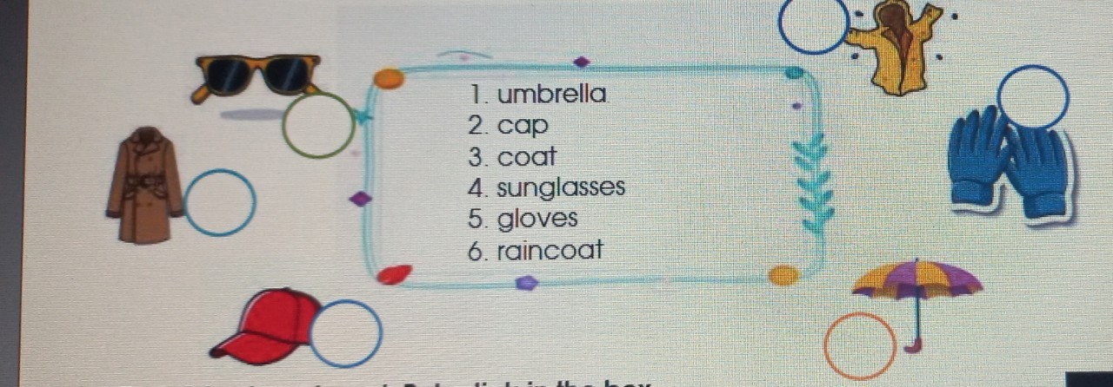
Part 3

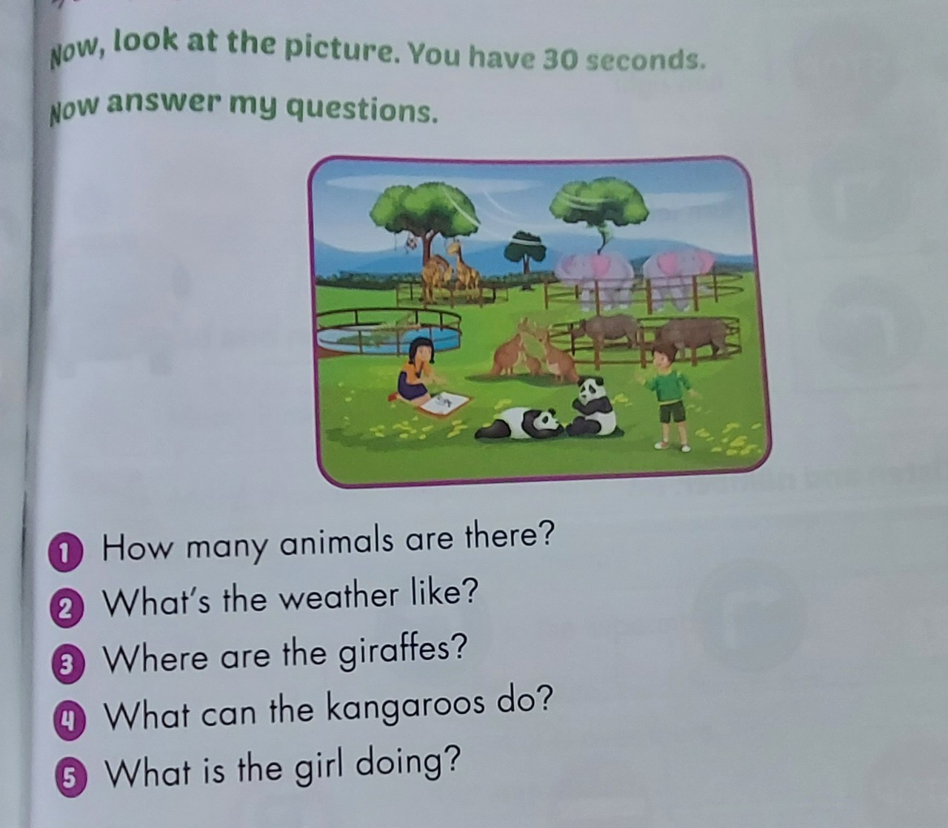

Part 4 ; Read and complete the sentences.

1. __________ is a kind of bird but it can’t fly. It can swim well.

2. __________ is a large reptile with a hard skin that lives in and near rivers.

3. __________ is large and lives in deserts.

4. __________ has black or brown and white lines on its body.

5. __________ has a long and strong tail. It moves by jumping on the ground.
6. __________ has a very long neck
Part 5 : Rearrange the given words to make correct sentences.
1. your/do/What/brother/can/?

2. you/Can/volleyball/play/?

3. sister/a/can’t/My/bike/ride/.

4. but/I/ I/can’t/dance/can hop/.

Part 6 ; Writing: Write about what your friends are doing in the breaktime.

III. Homework Assignment
- Review the vocabulary and grammar from Unit 1 to Unit 4.
- Prepare the new lesson.

